The American Saddlebred Museum
4083 Iron Works Pkwy Lexington, KY 40511 859-259-2746 asbmuseum.org

FOR IMMEDIATE RELEASE
CONTACT: Amy Nelson
859-396-0713
amy@asbmuseum.org

Equine Art, Antique, and Rare Book Auction
at the American Saddlebred Museum

LEXINGTON, KY–June 3, 2021—The Equine Art, Antique and Rare Book Auction takes place on Saturday, July 17, 2021 at 11:00 am at the American Saddlebred Museum, located at 4083 Iron Works Parkway, Lexington, Kentucky on the grounds of the Kentucky Horse Park. A preview will be on display at the American Saddlebred Museum Wednesday, July 14 – Friday, July 16, 9:00 a.m. – 5:00 p.m. and Saturday, July 17, 10:00 a.m. – 11:00 a.m. This year, the museum is pleased to offer online bidding via HiBid. Check the museum’s website for more information.
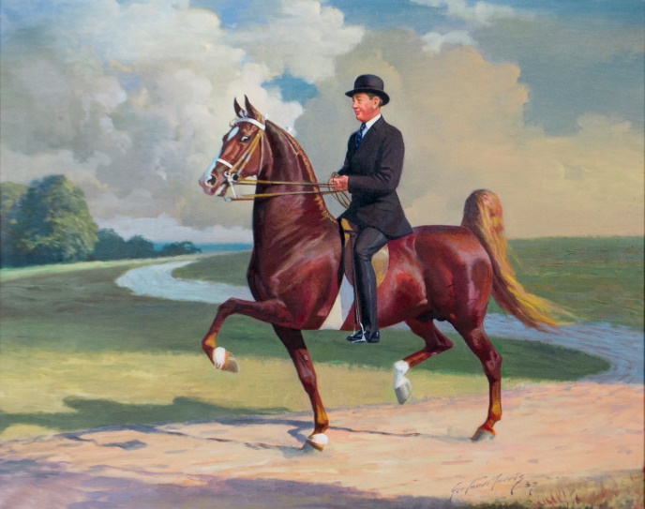
Executive Director Jennifer Foster says of the event “We are pleased to be holding the Art Auction this July. The great variety of items available from paintings to vintage advertising is outstanding. This sale has something for every horse lover.” The focus of the auction is particularly Saddlebred items, but coaching, Thoroughbred, Hackney and Morgan artwork are included. The auction draws and specializes in works by George Ford Morris, and includes examples of his work in pastel, oil, charcoal as well as lithographs.
George Ford Morris, Beau Peavine with William Capers “Cape” Grant Jr. up, Oil on canvas.

In addition to Morris, other artists represented include Carlos Arriola, Peter Barrett, Edwin Bogucki, Gladys Brown Edwards, Helen Hayse, Dawn Klein, Max F. Klepper, Hooshang Khorasani, Edward Penfield and many others.
The 2021 auction catalog is available online at https://www.asbmuseum.org/auctions-year/2021. Email museum@asbmuseum.org with questions.
########

