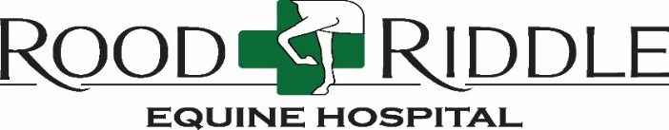

JOB TITLE: Barn Crew with Admissions Duties
GENERAL PURPOSE: To maintain the cleanliness and appearance of the barns and clinic grounds, in addition to providing excellent patient care. The position also requires the ideal candidate to be willing and able to assist the Admissions team as needed with particular job duties
EXPERIENCE: Horse farm experience preferred. Basic horse handling skills preferred
BENEFITS: Overtime compensation, 401(k), Dental, Health and Vision Insurance
SCHEDULE: 5 ½ days/wk.
* 2 half days, 7-11a.m.
* 4 full shifts; 7 – 3:30 p.m.
ESSENTIAL FUNCTIONS:
Physical: Position requires prolonged periods of walking and standing. Must be capable of lifting up to 50 pounds. Daily physical demands include squatting, bending, lifting, pushing/pulling equipment and/or patients to accomplish required duties. Vision must be correctable to 20/30. All job duties to be performed year-round and during inclement weather conditions.
Behavioral: Self-motivated individual who maintains an elevated level of productivity daily, while demonstrating the ability to work within a supportive team environment. Individual must be thorough in fulfilling daily job duties to meet quality RREH standards while abiding by strict safety & biosecurity protocols. Must maintain professional appearance and attitude at all times.
Organizational and Communicative: He/she must perform efficiently in fast-paced environment while communicating effectively with co-workers to ensure all patient needs are met in a timely manner. This position requires that employee must be able to read, write and comprehend English.

JOB RESPONSIBILITIES:
- Gain full understanding of, and adhere to all biosecurity protocols to include cleaning, washing and disinfecting patient stalls in individual barns and designated procedure areas throughout the clinic.
- Responsible for A.M. mucking & re-bedding of all overnight patient stalls
- Will be responsible for overall appearance and cleanliness of the barns
- Display exceptional horsemanship skills with all patients at all times
- Safely hold patients for bandage changes, medication administration, farrier work and/or bonescans
- Assist in loading challenging patients by using decided safe and effective tactics under supervision
- Provide quality, individualized patient care to include grooming as time allows
- Responsible for assisting in removal & transfer of deceased patients
- May be responsible for taking full muck trucks to dump site as needed
- Learn and follow proper protocol for admitting and discharging patients
- Keeping barns stocked with hay, grain & appropriate cleaning tools and disinfectant supplies
- Muck patient stalls, add hay & straw and fill/change water as needed throughout the day
- Assist with facility maintenance & upkeep as needed. Seasonal duties will vary
Contact Erin Mathes at emathes@roodandriddle.com

