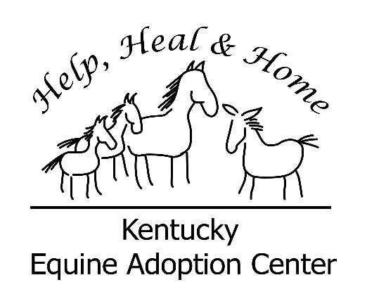
KENTUCKY EQUINE ADOPTION CENTER
POSITION DESCRIPTION

Title: Equine Care Assistant/Trainer (Full Time)
Purpose of Position:
At the direction of the Barn Manager, train and develop horses that are housed at the Center to a level of rideability, so that they can be adopted out to new homes. 50% of time is spent taking care of horses, and 50% of time is spent training.
Responsibilities:
Train all suitable horses at the Center through a program emphasizing natural horsemanship.
- Perform basic barn and horse chores: holding horses for veterinarians and farriers, medicating, daily cleaning and feeding.
- Train horses, based on a schedule provided by the Barn Manager
- Record notes of each training session on forms provided by the Center
- Upon request, show and ride horses to prospective adopters
- Ensure that KyEAC is represented in a professional and acceptable manner
- Provide assistant in times of equine emergency situation and disasters as requested by management
- Be available to assist in special events, open houses, and training opportunities as requested by management
- Take pictures of horses and put pictures and bios in albums on KyEAC employee FB page
- Assist in Take the Reins Education Program and Heads Up Hearts Open Equine Growth and Communication Program
- Perform other duties as assigned

Qualifications/training required:
Equine training experience required, with an emphasis on natural horsemanship
Previous hands-on experience with equines, including handling and care
Physically able to perform manual and demanding labor
Ability to work as part of a team in a positive manner; be able to work with minimal supervision
Ability to work closely with volunteers as needed
Provide own transportation; be on time and dependable
Notify Barn Manager and Executive Director in advance of any time away from farm when not scheduled in advance.

Send resume to info@kyeac.org

